Mario Bros User’s Manual

Hello! Welcome to Mario Bros!

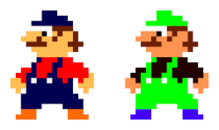This is Mario. He is an Italian plumber.

This is Luigi. He is Mario’s brother.

**Backstory of Game**

Mario and Luigi used to be top-ranked plumbers, living the luxurious celebrity life. They were recognized by all, and everyone respected their skills of being able to fix absolutely any clog. However, enemies have recently taken over the sewers of New York, putting Mario and Luigi out of their jobs since none of the plumbing works. The brothers have now taken on the role of removing these invasive creatures from the sewers, determined to regain their previously stable lifestyle.

**How to Play**

The player character is controlled by the WAD keys, with W corresponding to jump, A corresponding to moving left, and D corresponding to moving right. In 1 player mode, the player character is Mario; in 2 player mode, one player is Mario and the other is Luigi.

**Creatures**

There are four different creatures to look out for.

**Shell Creeper**

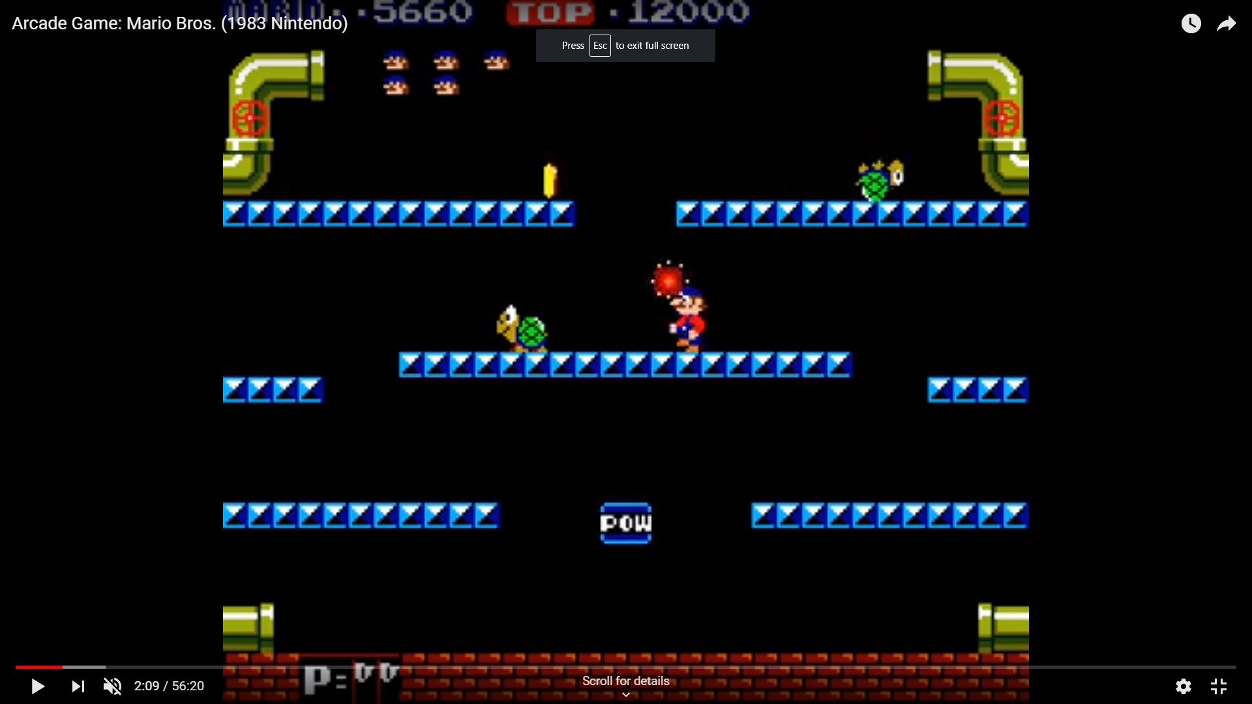 This is a shell creeper. Originally a teenage mutant ninja turtle, it was abandoned by the rest of the squad and has only found a home in the sewers.

To remove him, you must first hit the block underneath it to flip it over:

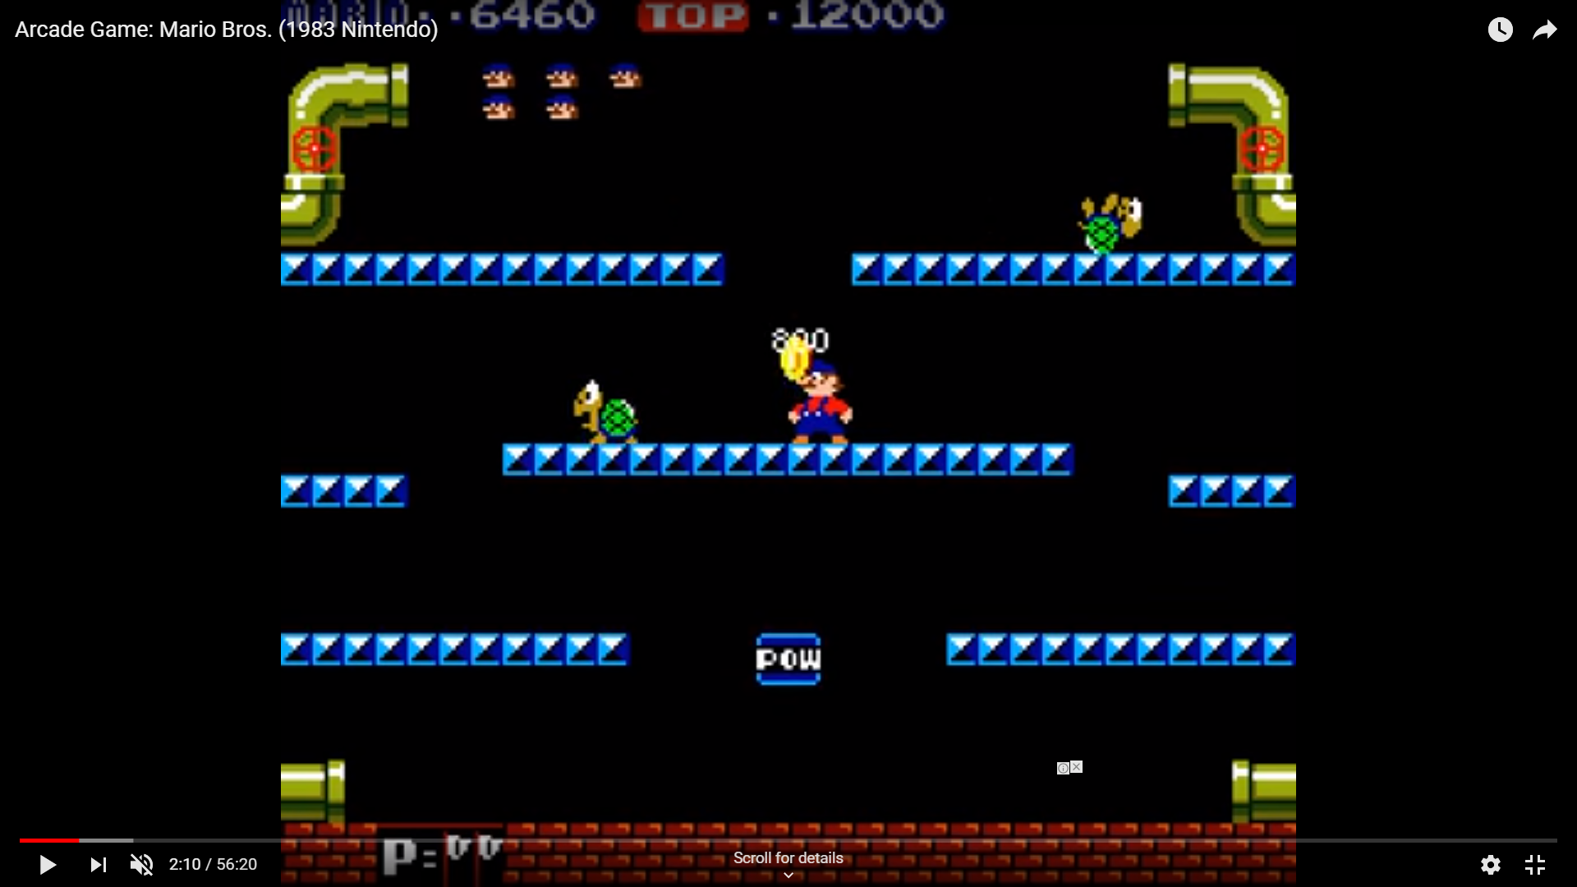

Now that it is in a vulnerable state, you may jump up to his platform and kick it out of the sewer,

**Sidestepper**

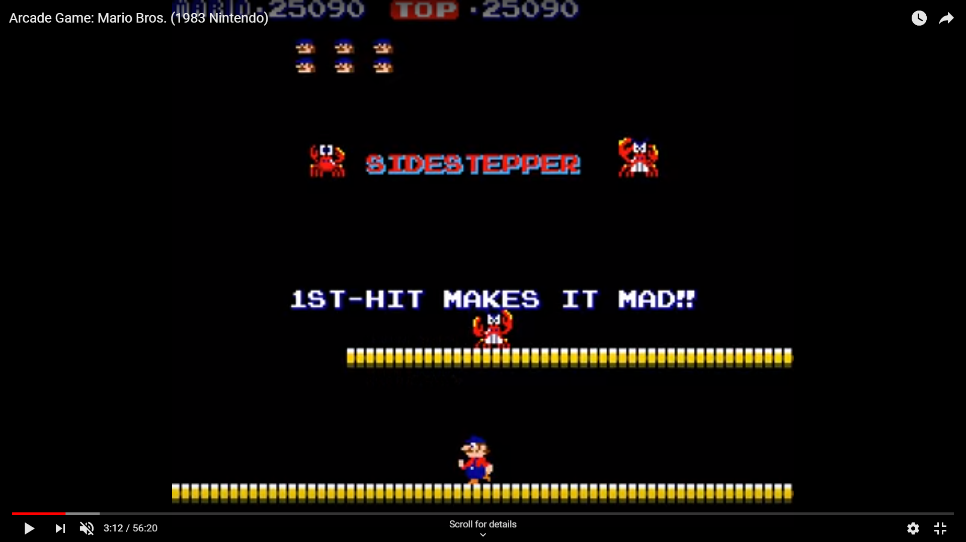This is a sidestepper. The original sidestepper was bullied out of the ocean due to being made fun of his face when he gets angry. It eventually stumbled upon the sewers.

To remove him, you have to hit the block underneath it. This will make it mad and look like this:



Then, you must hit again. This flips it over.

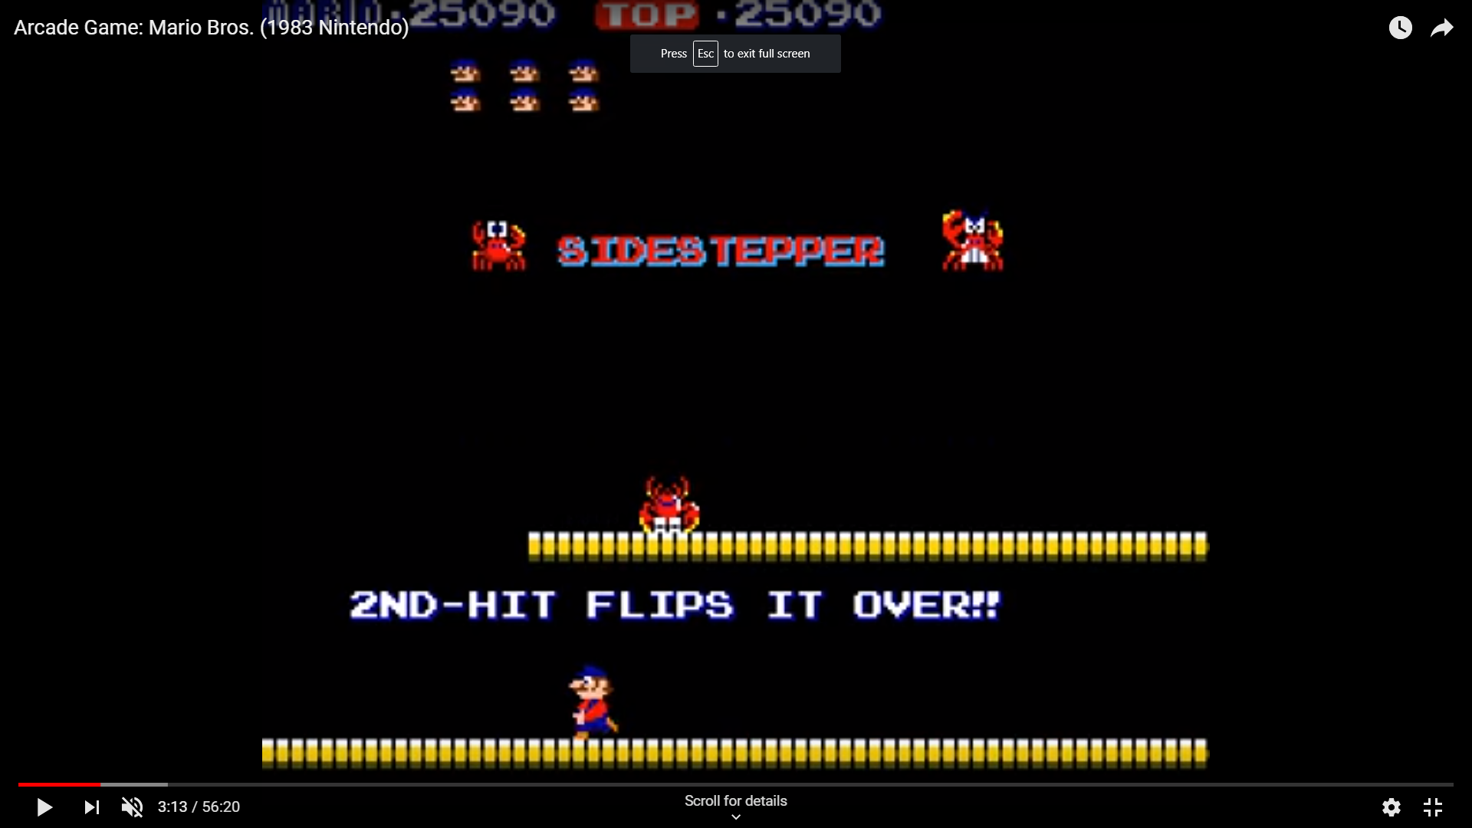

In this state, similar to the shell creeper, you must jump up to the platform and kick it.

**Fighterfly**

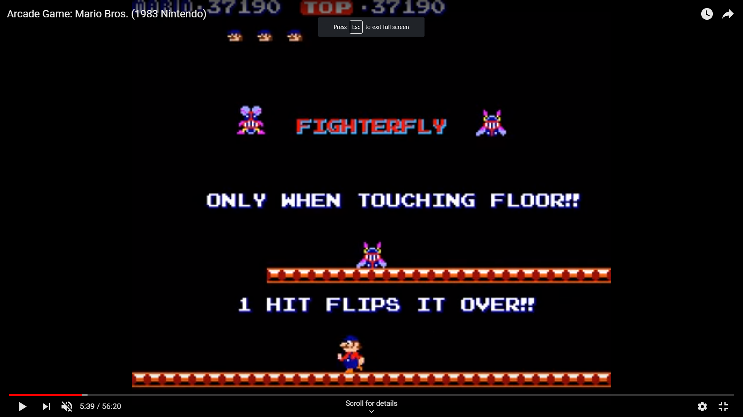This is a fighterfly. A science experiment gone wrong, the scientist in charge of it hid it in the sewers in the hopes that it would never be traced back to him.

It constantly hops up and down on a platform:

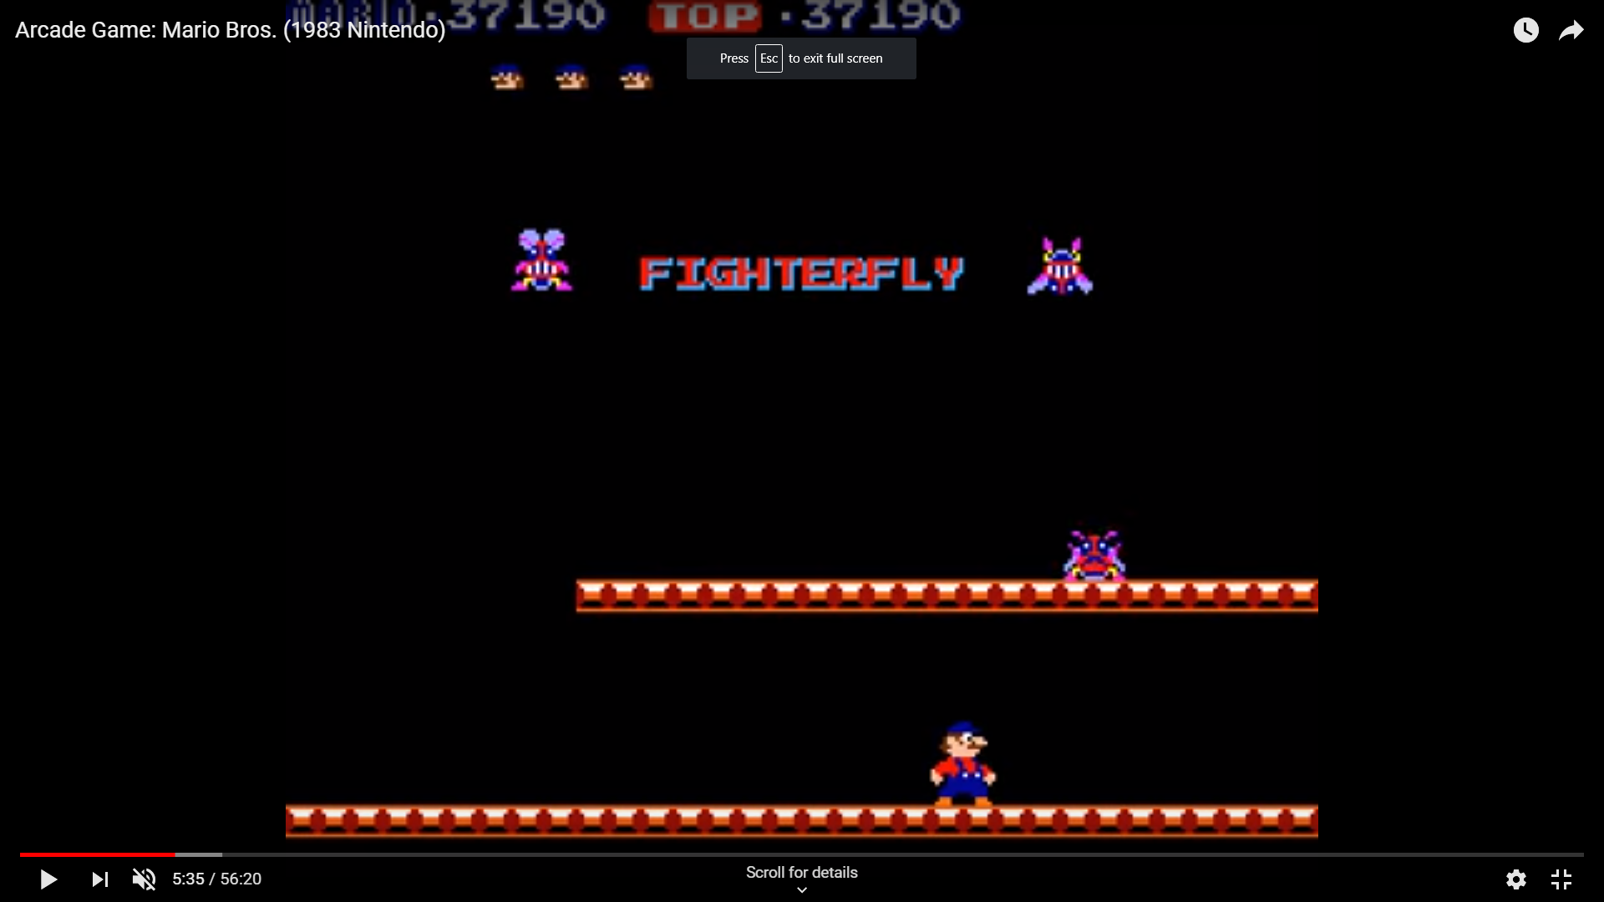

You must hit the block underneath it when it is touching the ground to flip it over.



You can then jump up to its platform and kick it.

**Slipice**

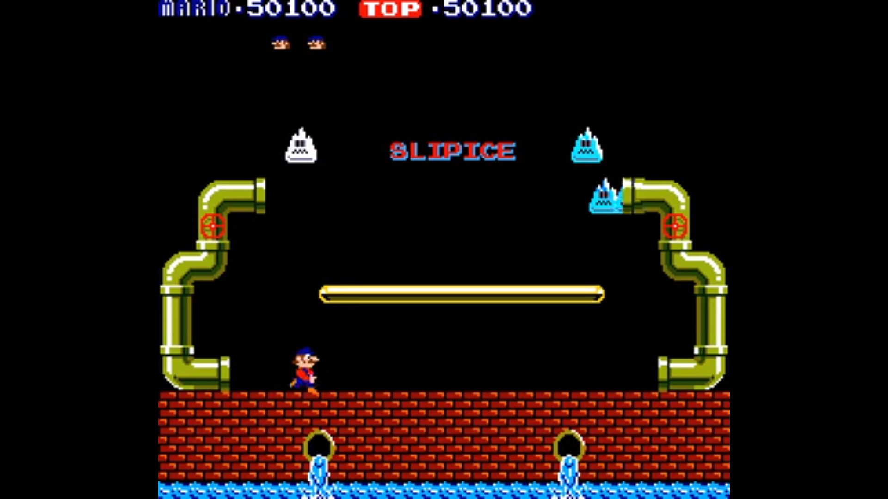 This is a slipice. Scientists were attempting to achieve absolute zero; the slipice is the closest that they got to this, but it went berserk. It froze them and then escaped, sliding into the sewers due to enjoying the damp environment.

Hitting the block underneath it immediately breaks it:

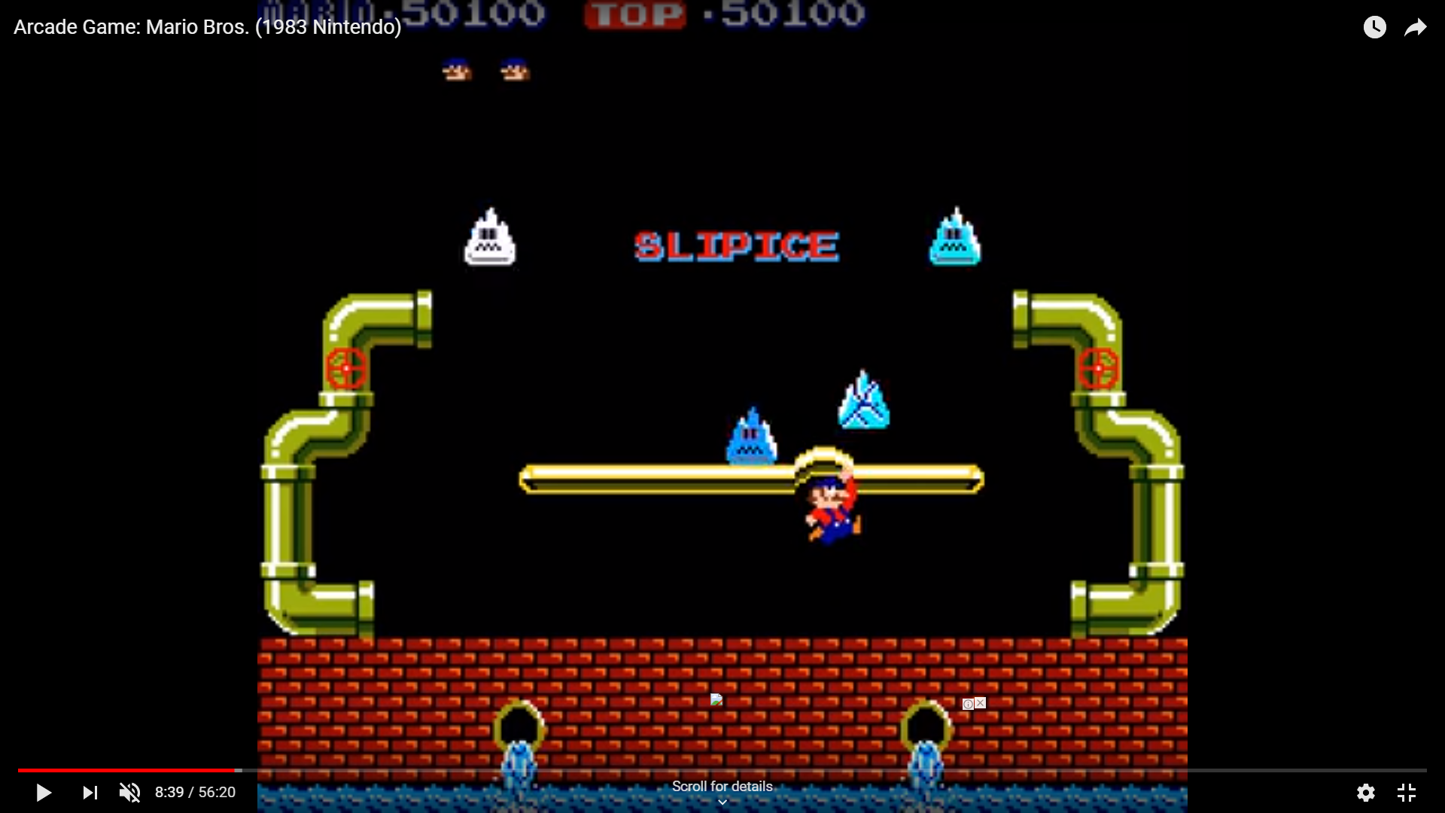

However, if it is left to its own devices, it makes the floor slippery.

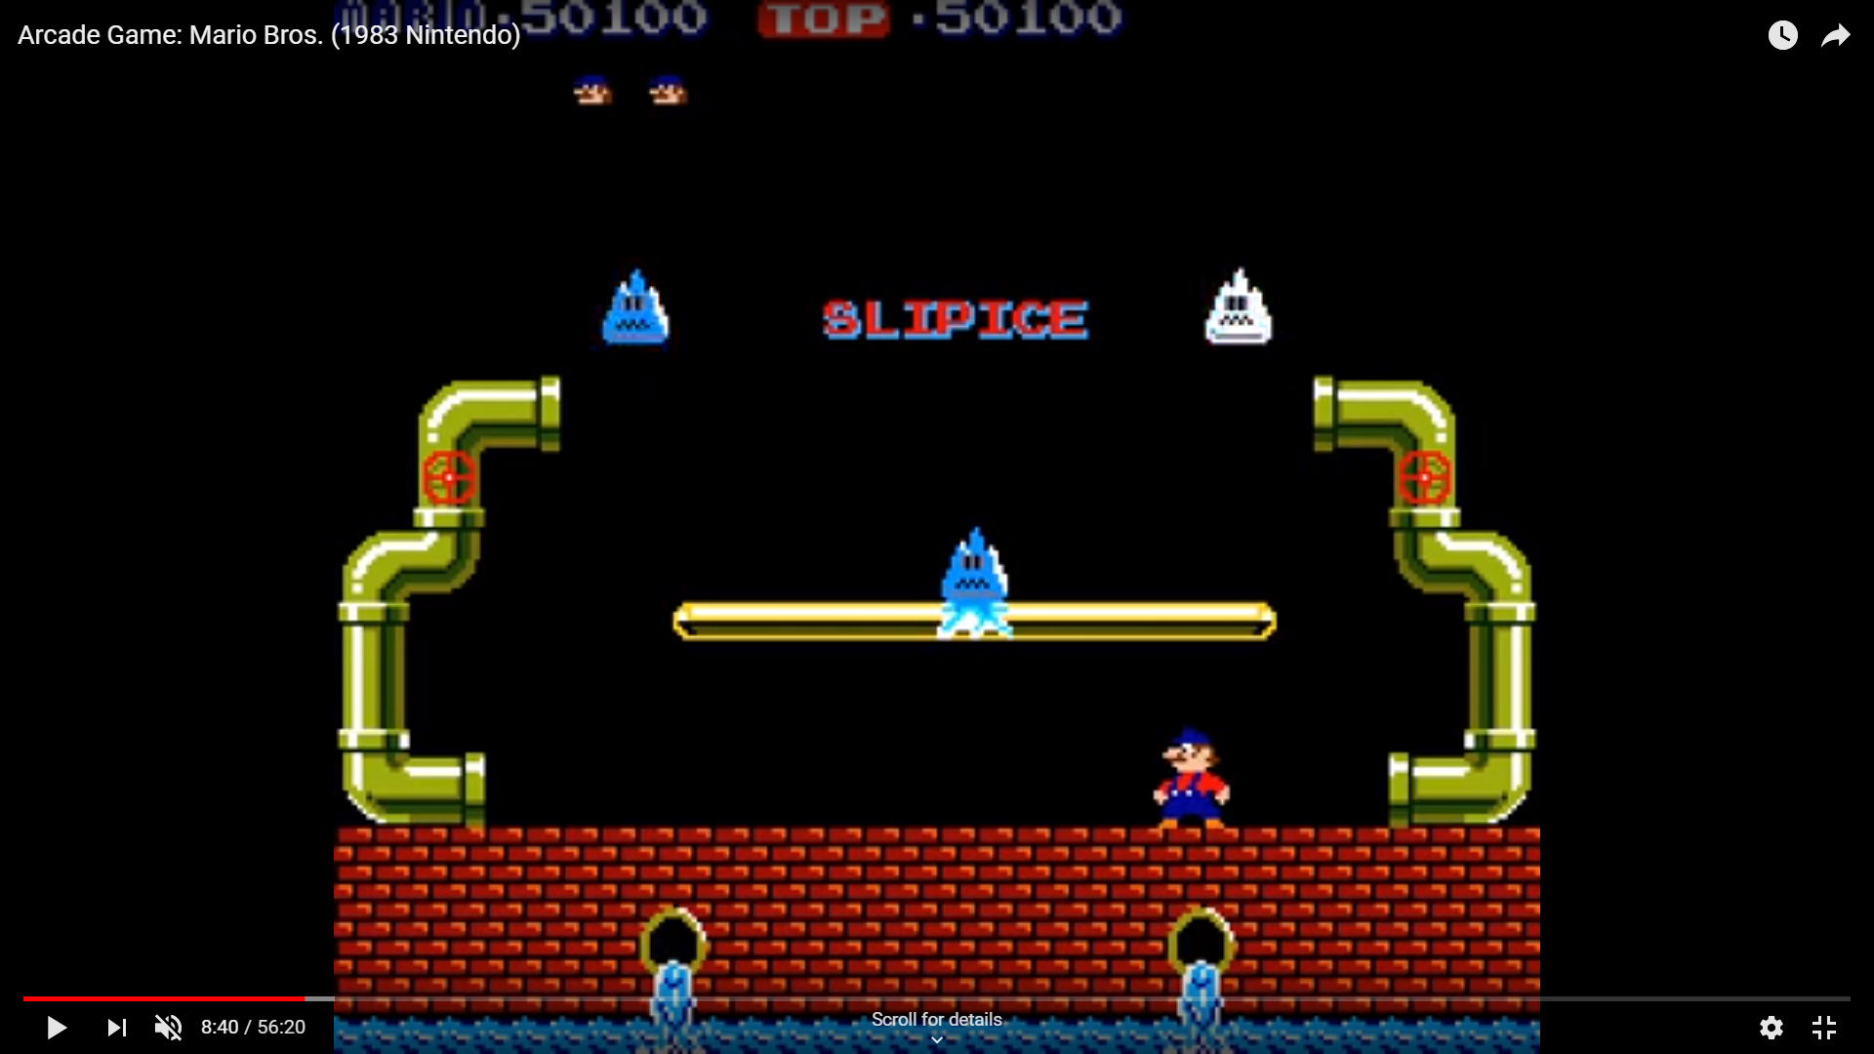

**Scoring**

Getting rid of the shell creeper, side stepper, and the fighterfly each reward you 800 points.

Getting rid of the slipice rewards you 500 points.

Each time that an enemy other than the slipice is defeated, a coin emerges from either the top left or top right pipe. Coins are worth 800 points.

**Message**

This game is clearly a message about human environmental destruction. Mario, a plumber in a relatively dead-end job, decides that destroying the creatures who have found a place that feels like a home is the best option for him to regain his previous status.